100 screen - main screen

101 screen – subscreen

102 screen - subscreen

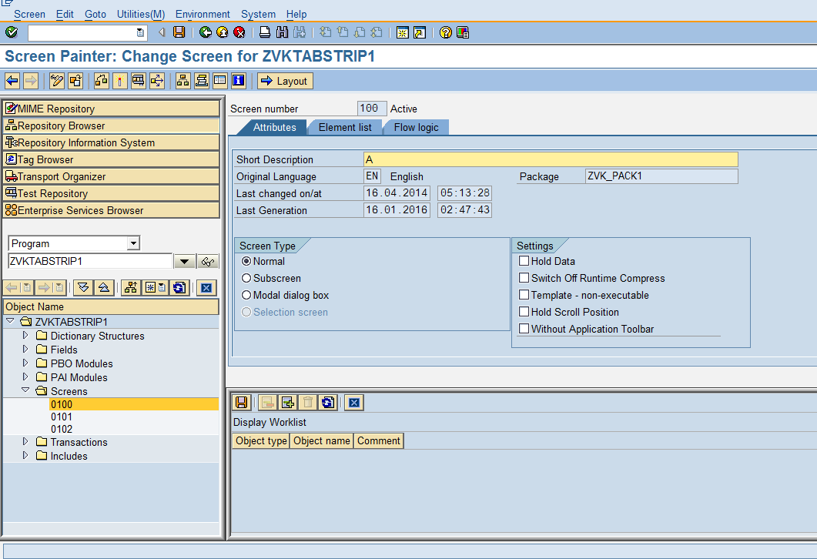

ENTER TABSTRIP NAME AS VMTS

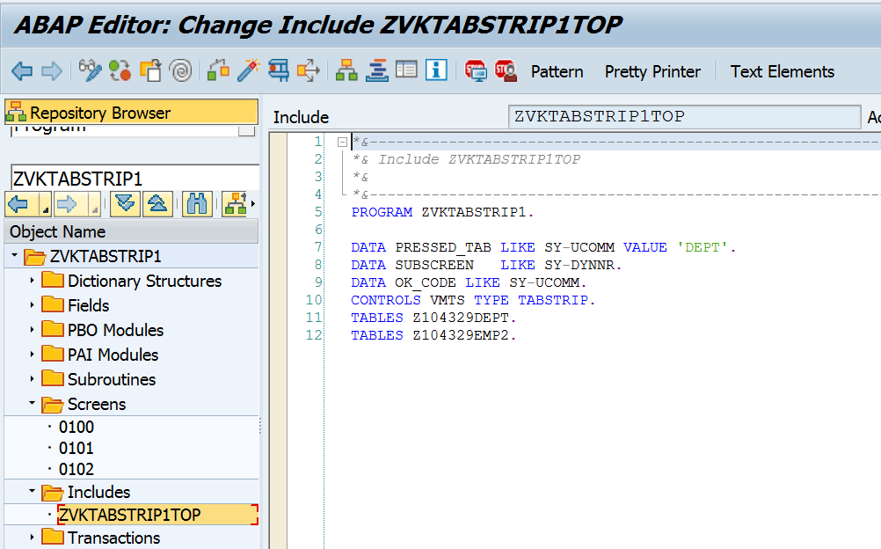

DATA PRESSED_TAB LIKE SY-UCOMM VALUE ’DEPT1’.  
DATA SUBSCREEN   LIKE SY-DYNNR.  
DATA OK_CODE LIKE SY-UCOMM.  
CONTROLS VMTS TYPE TABSTRIP.  
TABLES ZYNY_DEPT1.  
TABLES ZYNY_DEPT2.

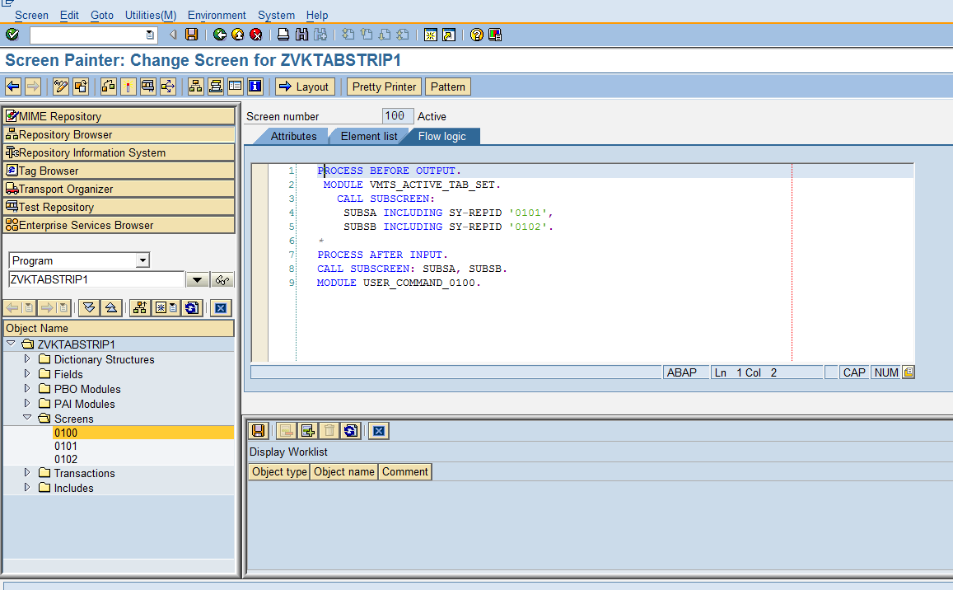

“CREATE SUBSCREEN ONE EACH FOR TABSTRIP NAMED SUBSA, SUBSB

PROCESS BEFORE OUTPUT.  
*\* MODULE STATUS_0100.*  
MODULE VMTS_ACTIVE_TAB_SET.  
CALL SUBSCREEN:  
SUBSA INCLUDING SY-REPID '0101',  
SUBSB INCLUDING SY-REPID '0102'.  
  
PROCESS AFTER INPUT.  
CALL SUBSCREEN: SUBSA ,SUBSB.  
MODULE USER_COMMAND_0100.

“--------------------------------------------------------------------MODULE VMTS_ACTIVE_TAB_SET OUTPUT.  
  VMTS-ACTIVETAB = PRESSED_TAB. *"DEPT*  
  CASE PRESSED_TAB.  
    WHEN ’DEPT1’.  
      SUBSCREEN = '0101'.  
    WHEN ’DEPT2’.  
      SUBSCREEN = '0102'.  
    WHEN OTHERS.  
  ENDCASE.  
ENDMODULE.

“--------------------------------------------------------------------MODULE USER_COMMAND_0100 INPUT.  
CASE OK_CODE.  
    WHEN ’DEPT1’.  
      PRESSED_TAB = ’DEPT1’.  
    WHEN ’DEPT2’.  
      PRESSED_TAB   = ’DEPT2’.  
    WHEN 'EXIT'.  
      LEAVE PROGRAM.  
ENDCASE.  
ENDMODULE.

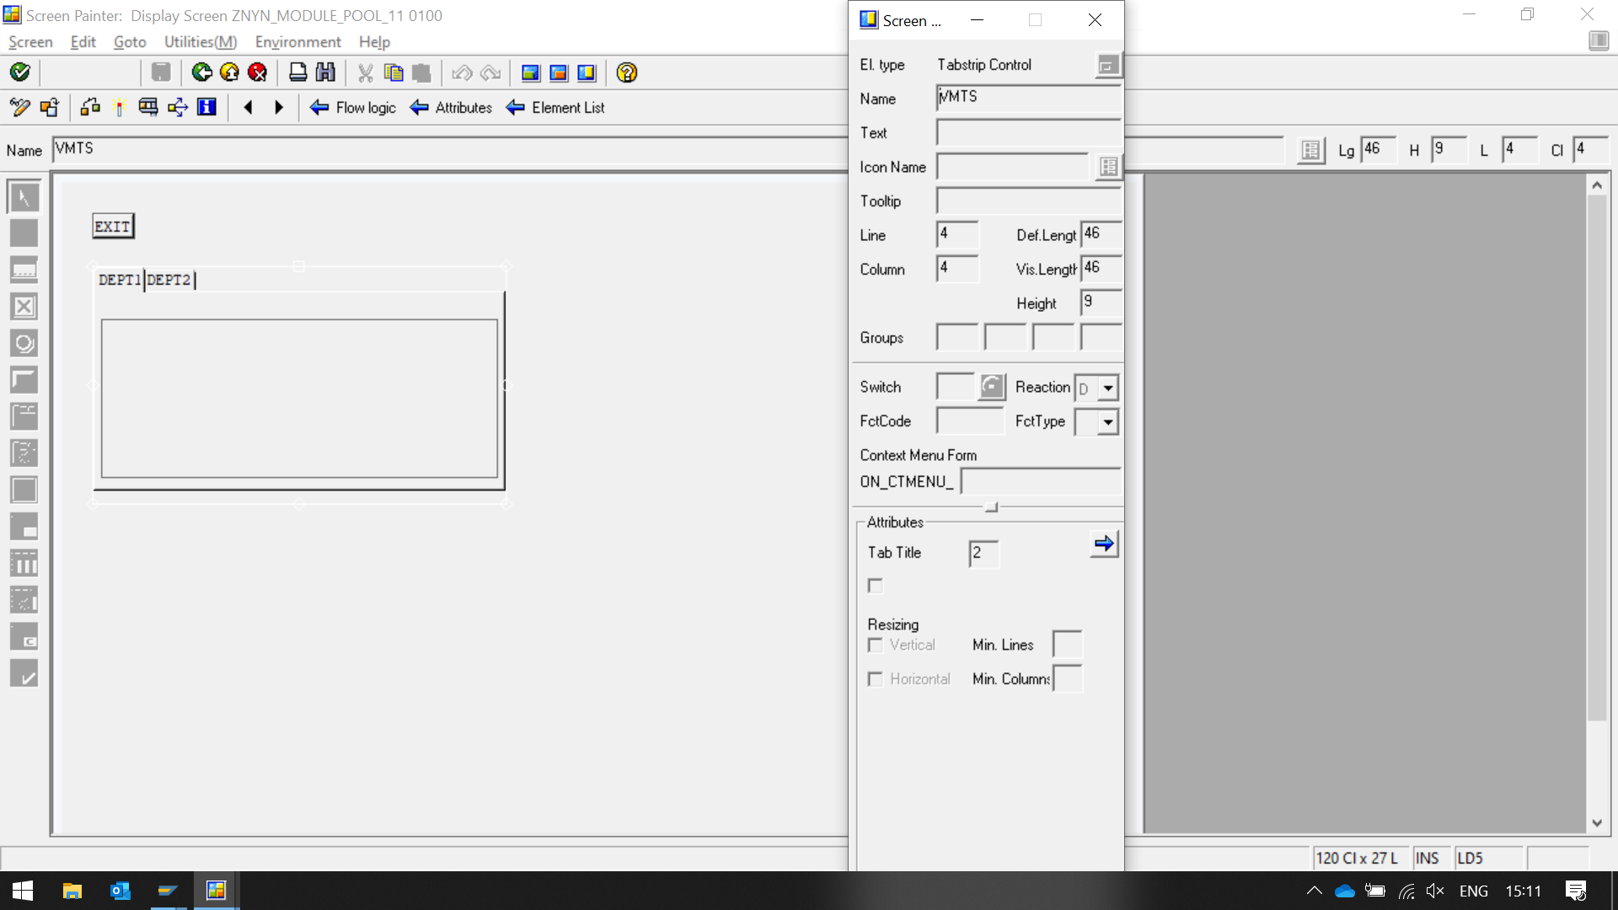

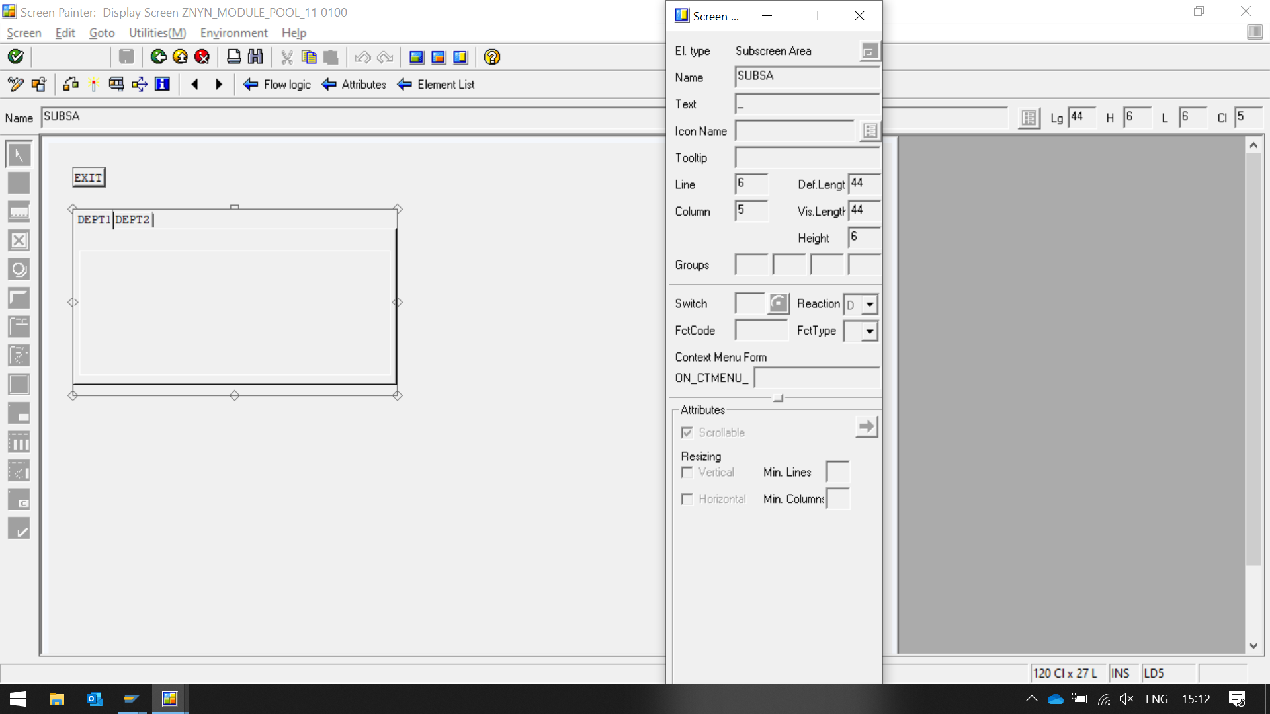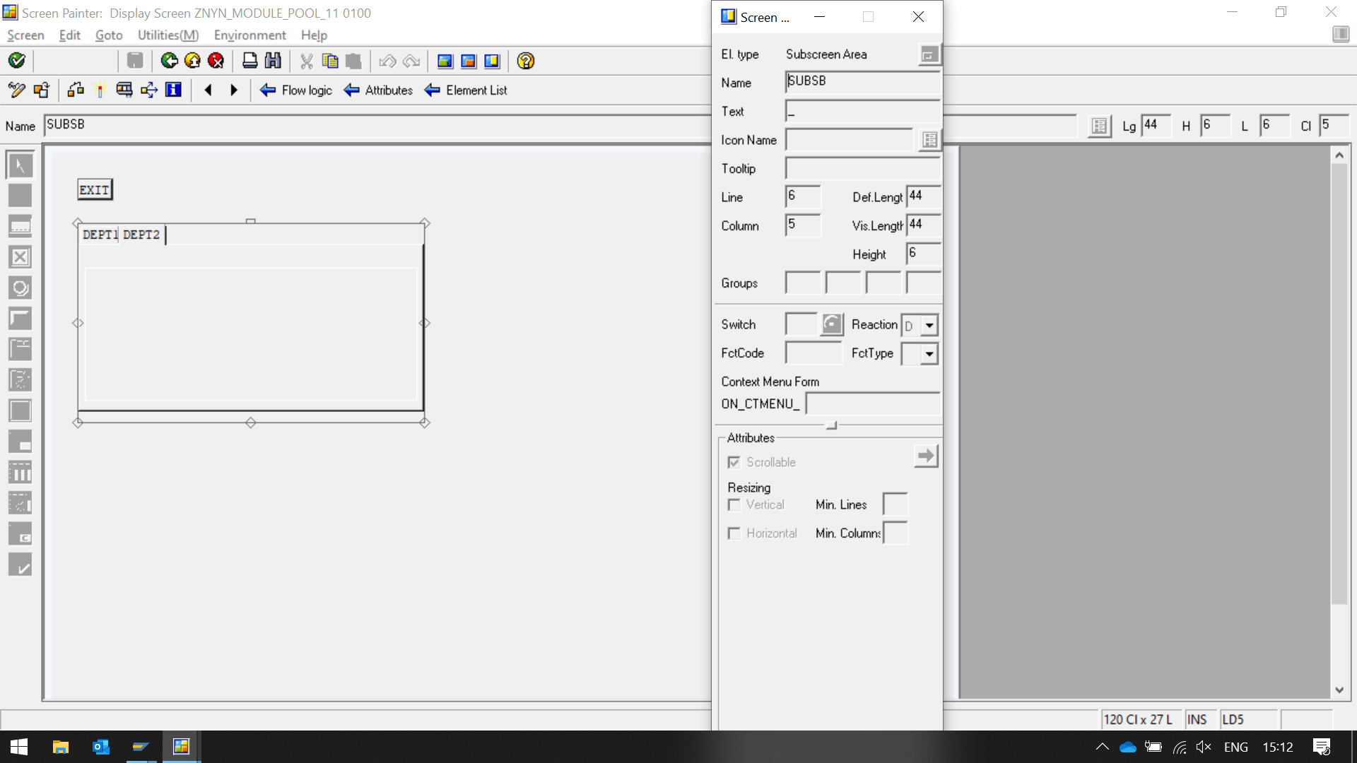

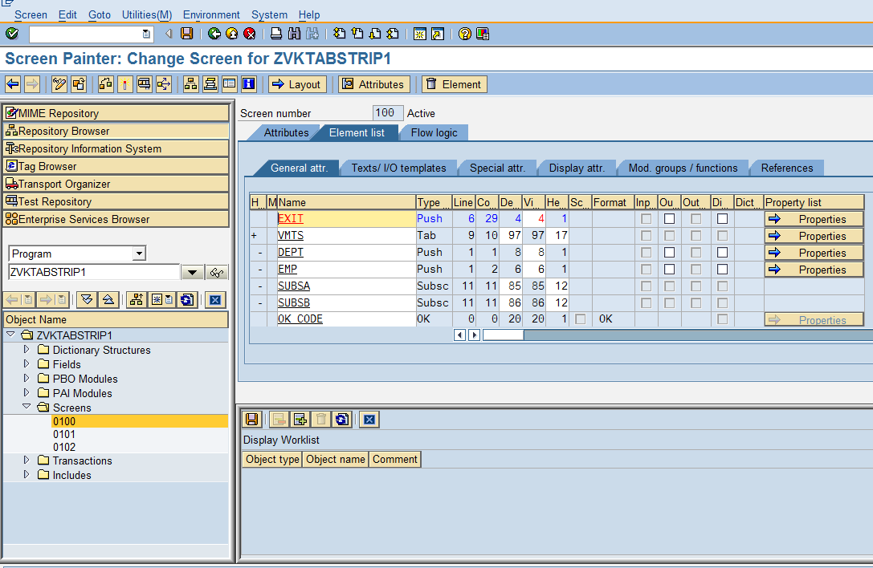

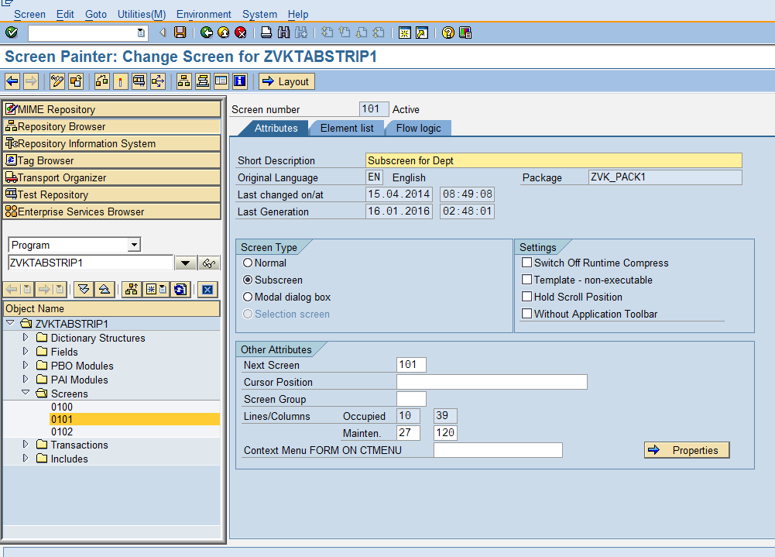

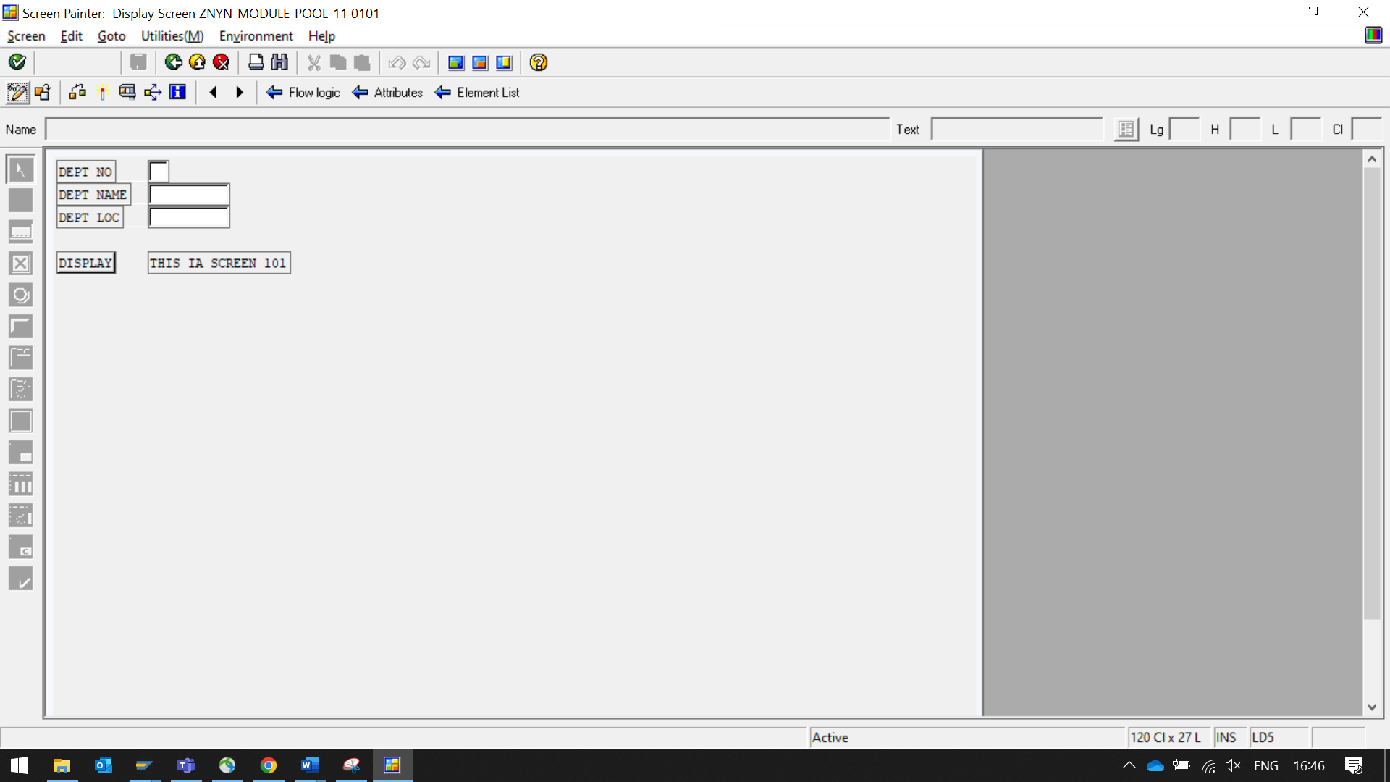

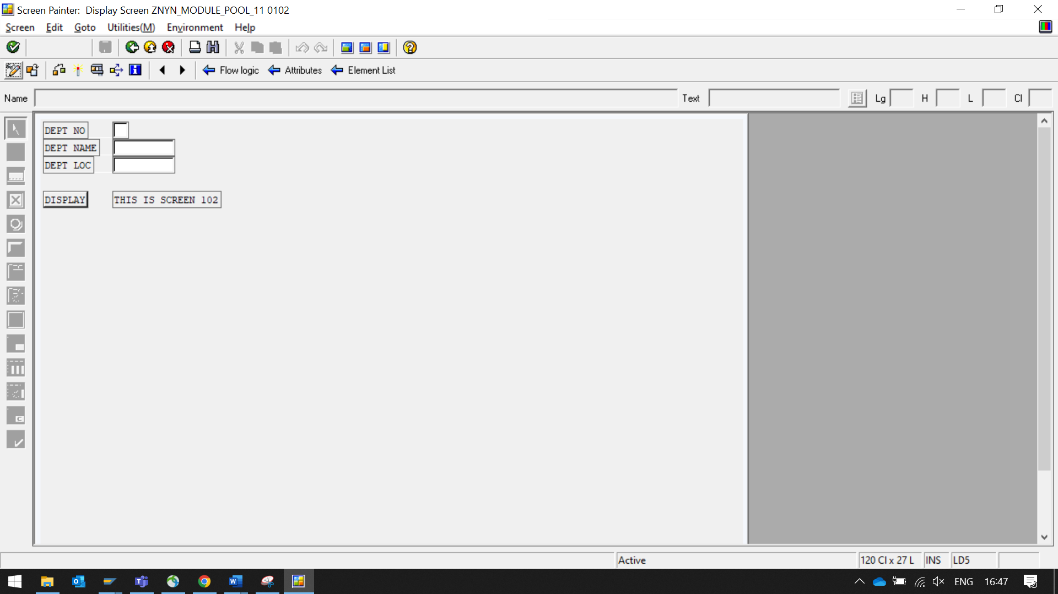

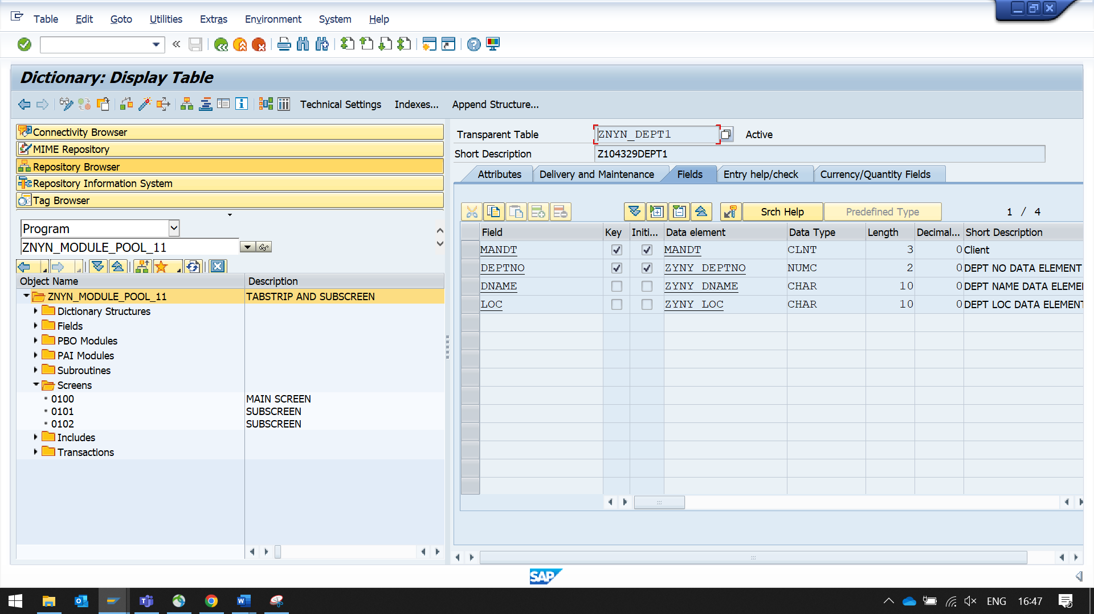

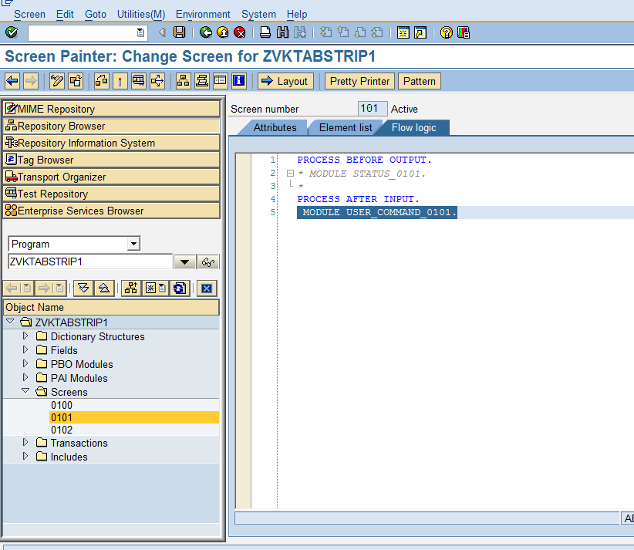

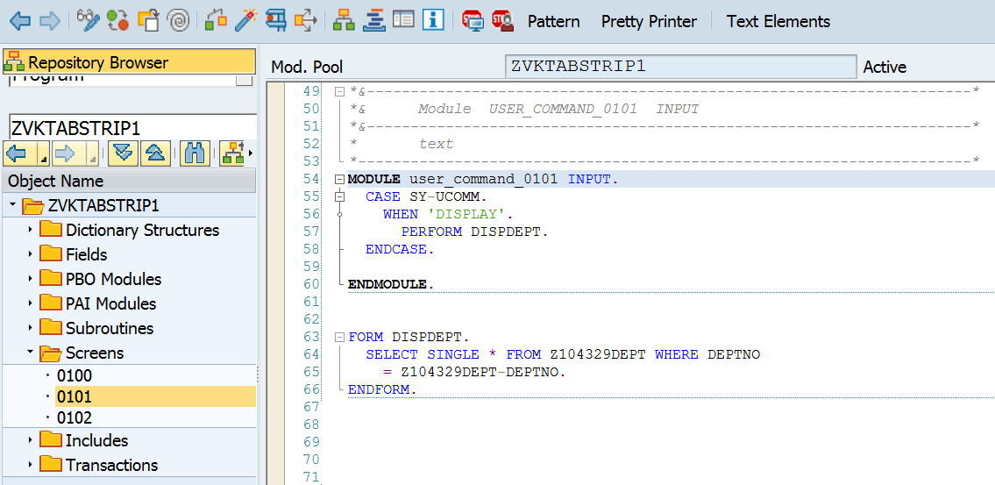

MODULE user_command_0101 INPUT.  
  CASE SY-UCOMM.  
    WHEN 'DISPLAY'.  
      PERFORM DISPDEPT.  
  ENDCASE.  
  
ENDMODULE.  
  
  
FORM DISPDEPT.  
  SELECT SINGLE * FROM ZYNY_DEPT1 WHERE DEPTNO  
    = ZYNY_DEPT1-DEPTNO.  
ENDFORM.

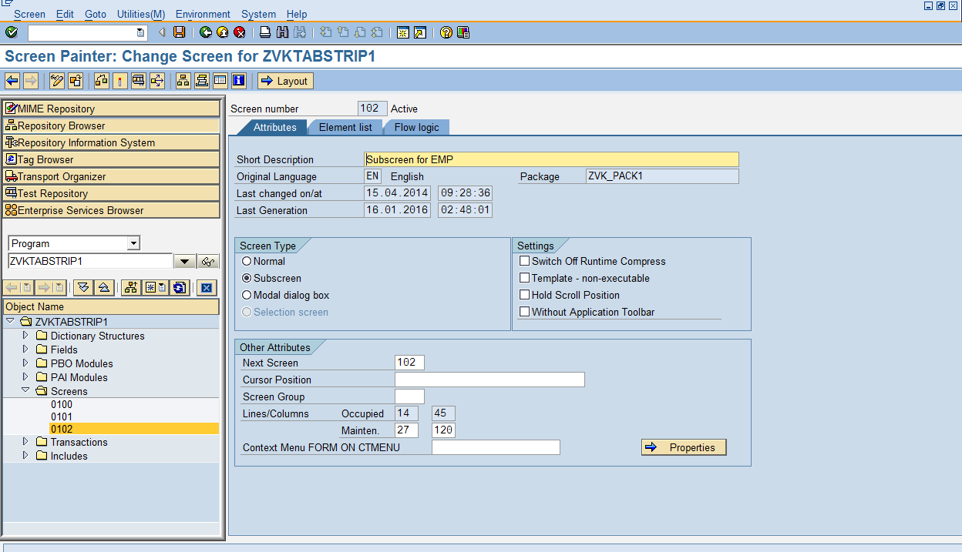

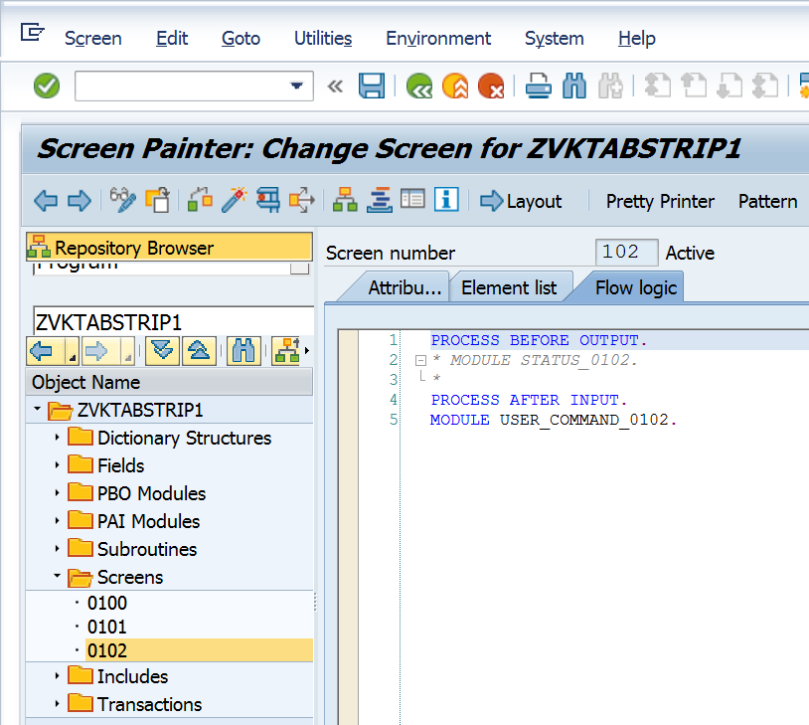

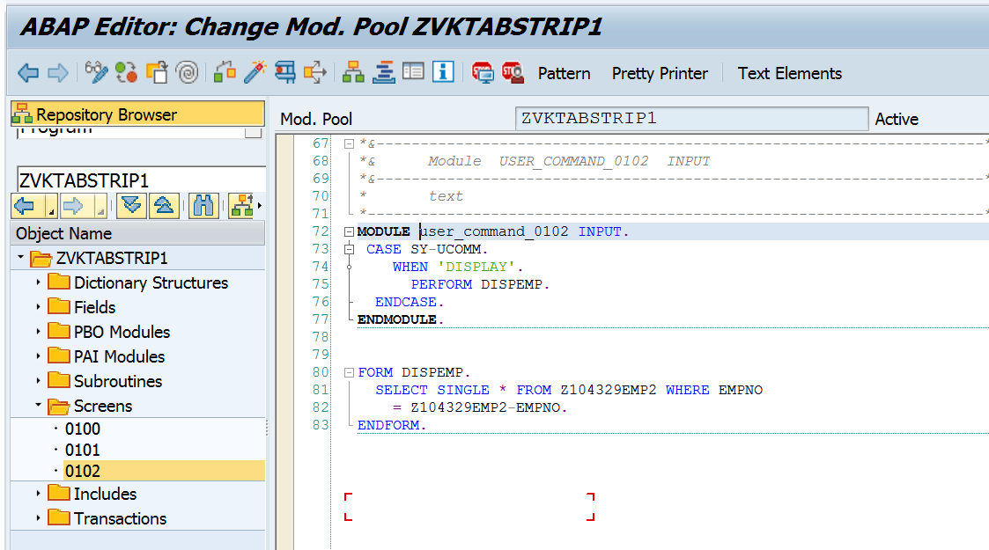

MODULE user_command_0102 INPUT.  
 CASE SY-UCOMM.  
    WHEN 'DISPLAY'.  
      PERFORM DISPEMP.  
  ENDCASE.  
ENDMODULE.  
  
  
FORM DISPEMP.  
  SELECT SINGLE * FROM ZYNY_DEPT2 WHERE EMPNO  
    = ZYNY_DEPT2-EMPNO.  
ENDFORM.

